Parallel Computing Logbook

Introduction
This logbook is the companion documentation for the UFCFFL-15-M UWE Parallel Computing module. Within this document are the details surrounding the development, testing, and concluding points for the AES brute force algorithm developed in tandem with OpenMP and MPI. The goal of the implementations is to increase the speed at which the brute force algorithm can achieve its goal, in order to test this, we have been pre-supplied with the necessary salted ciphertext that is also encoded in Base64, as well as its plaintext equivalent. Given these two, this project aligns with the crypto-analytical Known Plaintext Attack.

Table of Contents
Introduction 1
Logs of Progress 4
Session One - 31st October, 2019 4
Session Two - 7th November, 2019 6
Session Three - 9th November, 2019 7

Illustration Index
Illustration 1: Changed Code 4
Illustration 2: Changed Code, Segmentation Fault 5
Illustration 3: Change Code, Successful Generation 5
Illustration 4: Successful Serial Brute Force 6
Illustration 5: Successful Serial Brute Force, no gui 6
Illustration 6: Successful serial brute force, reversed search vector 6
Illustration 7: Successful serial brute force, no gui 6
Illustration 8: Successful OpenMP parallel brute force, three threads 7
Illustration 9: Successful OpenMP parallel brute force, reversed vector, three threads 7
Illustration 10: Successful OpenMP parallel brute force, four threads 7
Illustration 11: Successful OpenMP parallel brute force, reversed vector, four threads 7

Logs of Progress

Session One - 31st October, 2019
The goals of this session was to create working brute force algorithm and to demonstrate it working by having it crack the target serially. Once it is known that the program works serially then reconfiguring it utilising OpenMP and OpenMPI would be simpler, as the development wouldn’t involve testing both the algorithm and the parallelisation simultaneously. If it is certain that the algorithm works serially, then any issues that arise in the later stages would be solely due to the newer additions.

The brute force algorithm is a modified version of the provided algorithms, being extended from checking three levels of permutations to five, this stage is much easier than previously anticipated due to the knowledge that the key we are attempting to find will certainly be five characters in length including “a-z, A-Z, 0-9”. This fact removes the need to dynamically resize the string we are generating and instead just create a string of size 5 with permutations of the aforementioned character sets.

Resultantly, instead of using the method within the provided algorithm, it was instead opted to use a hard coded character set and arrange the string using that instead of calculating the value of an ASCII character like it was previous, this created the basic brute forcing algorithm.
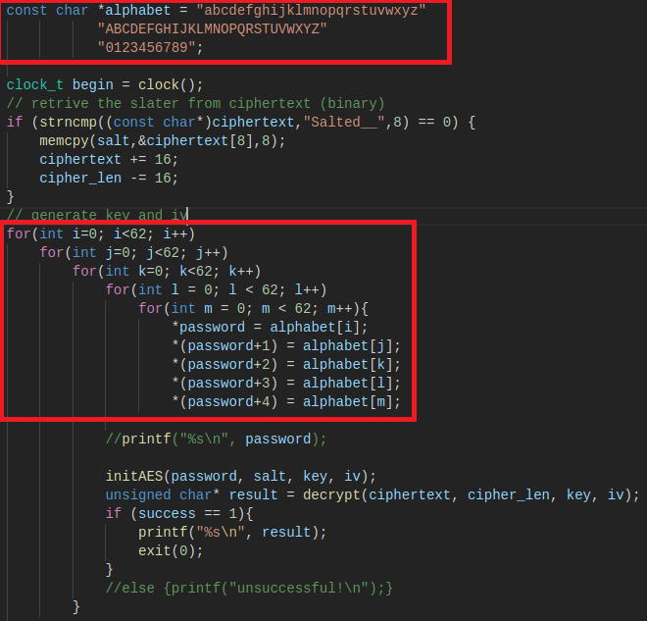Illustration 1: Changed Code
This was then tested as previously mentioned, however it was not as simple as previously thought.
At first the brute force algorithm began segmentation faulting, usually this would be due to a data structure being overflowed or possibly an incorrect input being passed somewhere. The latter is out of the question, as the program has hard coded inputs and there are no varying type functionalities. The former is difficult to judge, as the program utilises few data structures and those that are used do not see the massive amount of data being generated by the brute force algorithm.
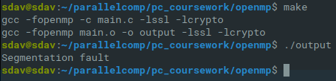Illustration 2: Changed Code, Segmentation Fault
In order to test what was causing the segmentation fault I separated the AES decrypting code from the brute force code I had developed and ran the latter on its own to see if it was the one causing the fault, and it was not.
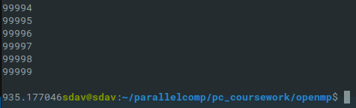Illustration 3: Change Code, Successful Generation
The brute force itself is capable of running to completion even when printing to the command line, which usually uses more resources. The only thing excluded from this sequence was the AES OpenSSL decrypting code, meaning the segmentation fault occurs there.

Session Two - 7th November, 2019
After some extensive communication with Kun Wei the brute force algorithm was reviewed and fixed to the degree where it is now working as intended. The fix was freeing memory after attempting to decrypted the string each pass and adding a plaintext checker for two levels of authentication when trying to find the correct decryption.

With this solved I can now test the brute force algorithm serially, without any parallel computing modifications. This is conducted solely so that there is something to compare the performance of the parallel versions of the algorithm to, and so that we can review any differences in time taken between the three implementations. Due to the prolonged nature of brute force algorithms, we can assume that computing one in parallel rather than serially would drastically speed up the computation.

The search vector for the algorithm works along “Numbers → Upper Case → Lower Case”, the search vector was decided to match the ascending order that ASCII characters would occur. The first run has revealed that the target password occurs relatively early in this search vector, with the password being 12Dec, meaning that the cracking only takes around 35 seconds.
Then without the terminal output for every variation:
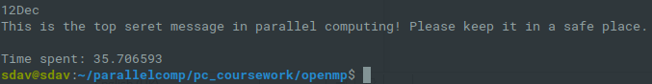Illustration 4: Successful Serial Brute Force
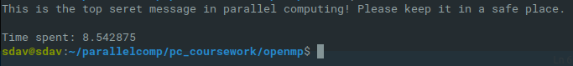Illustration 5: Successful Serial Brute Force, no gui
For the sake of an active comparison, we will also test what the cracking time would be like if the target was towards the end of the search vector, that is with the vector occurring “Upper Case → Lower Case → Numbers”.
Then without the terminal output for every variation:
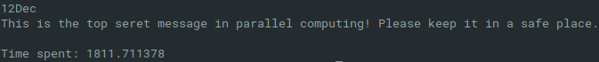Illustration 6: Successful serial brute force, reversed search vector
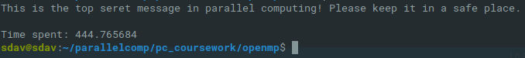Illustration 7: Successful serial brute force, no gui
The algorithm predictably takes considerably longer.

Session Three - 9th November, 2019
The method of OpenMP parallelisation decided upon was a fairly obvious one, the brute force algorithm utilises five nested for loops in order to achieve its function, and the OpenMP library introduces the concept of parallel for with the clause of collapse(n), with n being the amount of loops within that you wish to combine. Given this, each thread will handle a single iteration of all of the loops at once.
Testing this on the first search vector “Numbers → Upper Case → Lower Case” yielded some strange results. The algorithm was ran with three threads, and took longer to complete.
However, running the same three thread algorithm with the reverse search vector “Uppercase → Lowercase → Numbers”, actually causes it to find the solution faster.
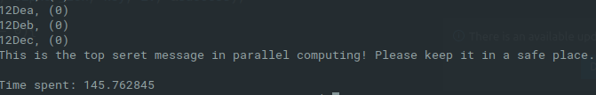Illustration 8: Successful OpenMP parallel brute force, three threads
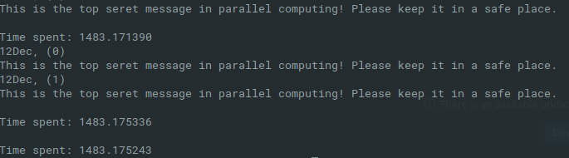Illustration 9: Successful OpenMP parallel brute force, reversed vector, three threads

It was decided to continue researching this approach, and the amount of threads was increased from three to four. Once again, the first search vector proved slower, even than that of three threads, but not considerably.
Then, with the reverse of the vector, it proved considerably faster than not only its serial version, but also faster than the three thread version.
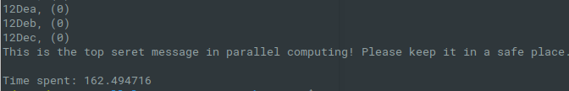Illustration 10: Successful OpenMP parallel brute force, four threads
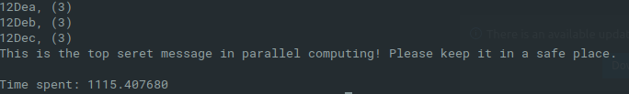Illustration 11: Successful OpenMP parallel brute force, reversed vector, four threads

METHOD OF PARALLELISATION
<< Provide details of parallelisation approach, referring to renown taxonomies and approaches; e.g. SIMD/MIMD etc, Data Parallelism, Task parallelism. A good reason should also be provided for why the identified parallelism is adopted. This section should not exceed 500 words. >>

Performance Analysis

Testing Table
Test | Threads | Forward Vector | Reverse Vector
Serial | n/a | 35.706593 | 1811.711378
Collapse() | 2 | 238.907300 | 5205.874778
Collapse() | 4 | 162.494716 | 1115.407600
Collapse() | 6 | 237.772732 | 531.256776
Collapse() | 8 | 329.376235 | 2384.765861

<< Experimental and test results should be collated in this section in tables(s). Comparative analysis and discussions can be provided with help of plotted graphs and other possible visual materials, wherever appropriate. The analysis can be developed referring to theoretical lows, rules, and models, such as Amdahl’s Law, Gustafson Law etc. This section should not exceed 2000 words. >>

CONCLUSIONS
<< Draw upon the evidence and analysis presented in the previous section, together with any relevant and useful sources, to derive conclusion(s) >>

REFERENCES
<< List references using Harvard style >>

